Part 1

Description
An elementary school has requested you to implement an application named “Geometry for kids” to help young children understand how surface area of various two-dimensional shapes is calculated:

- The default screen will ask the user to select a shape from a drop-down list:
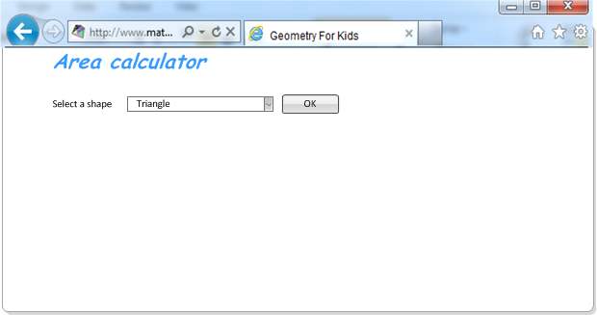

- As soon as the user selects the shape and clicks on OK button, the system will display a .gif picture with area calculation formula for the chosen shape. The system will also provide a calculation section where user could provide values for the shape parameters and click a button to calculate area:

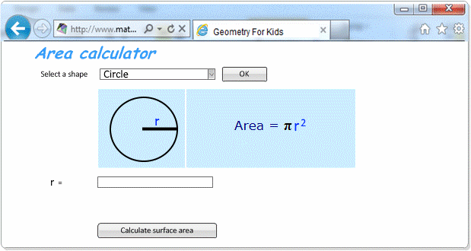
or
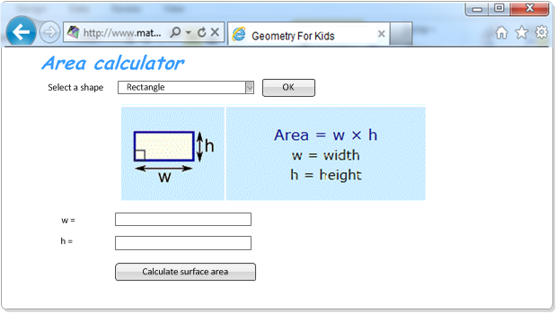

- Once the user clicks on Calculate surface area button, the system calculates the area based on the values the user has supplied and displays the calculated area value as follows:

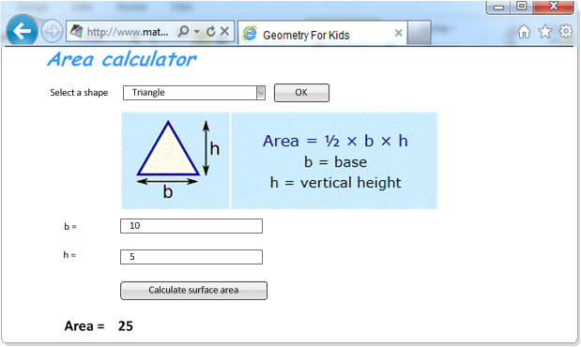

At this stage, user can change the values of the parameters and re-do the calculation or can select a new shape.

Business requirement
Implement the application described above using one of the following:
- Web application - ASP.NET (classic or MVC), Vue
- Desktop applications (e.g. Winforms, WPF)
- API – Implement an API which can be called to for any of the shapes, taking the dimensions as parameters and returning the calculated area. The APi can be implemented in any of .NET Framework, .NET Core (.NET 5, 6 , 7), WCF.
  - Please supply a short document describing how the API should be called
Use the .gif pictures and the formulas provided in the shapes.zip.
NOTE: The screenshots above are for guidance only. You can choose your look & feel and GUI framework of choice to build the screens.

Technical requirements
- As children progress with the geometry study, new shapes will have to be introduced (i.e. hexagon, parallelogram, circle, sector, etc.). It shall therefore be possible to add new shapes into the application with minimal changes in the existing code (the less c# code changes needed to add new shapes, the better the solution will be evaluated).
- Not all shapes have the same number of parameters (for example, the circle or a square only has one parameter, while an ellipse or rectangle have two). Try to make your code adaptive so that additional shapes can be added with varying numbers of parameters.
- OOP and design principles that should be used:
  - Encapsulation
  - Polymorphism
  - Separation of concerns
  - Factory pattern

Test preparation
The solution should be created in Microsoft Visual Studio. You may use any of the Visual Studio editions you have available on your computer. If you do not have Visual Studio installed on your computer, please download a free version from here:
https://www.visualstudio.com/downloads/
Once you have implemented the required application, zip all the source code files in the solution (make sure you remove all binary files from the bin and obj subfolders) and upload the zip to e-recruit

Part 2

- What is the difference between relational and non-relational databases?

Relational databases are built on a structured, tabular format with established relationships and a fixed schema; whereas non-relational databases support more flexible data models and can be schema-less or dynamic. SQL and MongoDB are two examples of databases that cater to various data requirements and use cases.

Relational databases are structured around the concept of tables with predetermined relationships. They define the data structure using a set schema.

- Relational databases store data in tables made up of rows and columns. Each row is a record, and each column is a single attribute or field. Primary and foreign keys are used to establish relationships between tables.
- Relational databases impose a tight schema in which the structure of the database is established prior to data inclusion. Existing data may need to be edited or moved if the schema is changed.

- SQL (Structured Query Language) is the standard language for querying and manipulating data in relational databases. SQL querying provides significant features for retrieving, modifying, and connecting data. e.g. Consider using a relational database for a e-commerce site. It could feature tables for customers, orders, and products, with essential relationships establishing relationships. To extract relevant data, utilize queries such as

"SELECT * FROM Books WHERE BkID = 23 or "JOIN" statements.

On the other hand;
Non-Relational Databases (NoSQL): Non-relational databases, often known as NoSQL databases, provide greater flexibility in data storage and retrieval. They employ a variety of data models and do not impose a single schema. Here are a few crucial points:

- NoSQL databases use a variety of data models, including key-value pairs, document-based, columnar, and graph-based formats. This makes it easier to store unstructured or semi-structured data.
- NoSQL databases are usually schema-free or have a flexible schema. Each record in a collection or document can have a unique structure, allowing for more adaptability to changing data needs.
- Query Language: Depending on the data model used, NoSQL databases may have their own query languages. Some also support SQL, while others offer data access APIs.
- MongoDB, for example, is a well-known document-oriented NoSQL database. A document-based database can be used in a blogging platform to store blog entries as JSON-like documents with varied structures. Depending on the blog post, each document may contain different fields such as title, content, author, and tags. NoSQL databases are ideal for dealing with such fluid and diversified data.

- What is the difference between a spark job and a MapReduce job?

Spark framework integrates with a variety of data sources, including Hadoop, and Amazon S3. It works better with contemporary data processing frameworks, machine learning libraries, and streaming platforms. It delivers a more flexible and efficient data processing architecture effective in iterative workloads, interactive analytics, and sophisticated data processing jobs.
However, MapReduce framework works with existing Hadoop infrastructures and batch-oriented processing.

- Process Model:

MapReduce: Map and Reduce phases make up MapReduce. Key-value pairs are mapped to intermediate outcomes and reduced to the final output in simultaneously.
Spark: A more flexible and expressive processing model. It allows directed acyclic graph (DAG) workflows that integrate filtering, transformation, and aggregation. Spark's API supports SQL queries, machine learning, and graph analysis.
Speed:

MapReduce: MapReduce is faster for batch processing than iterative and interactive workloads. Every level reads data from disk, increasing delay.
Spark: Spark accelerates iterative algorithms and interactive analytics with in-memory processing and caching. Data is stored in memory between phases, decreasing disk I/O and speeding up access.

- Data processing:

MapReduce: MapReduce processes key-value pairs. It uses disk-based intermediate storage and explicit serialization and deserialization.
Spark: Flexible data processing model. RDDs, Data-Frames, and Datasets are supported. These abstractions enable high-level operations on structured and semi-structured data, making Spark appropriate for complicated analytics jobs.
Fault tolerance:

MapReduce stores intermediate data on disk for fault tolerance. Recalculating data from interim findings if a node fails.
Lineage information makes Spark fault tolerant. It tracks operations made to an original dataset to recover lost partitions. Spark recovers from errors by performing lost partitions on other nodes.

- What gateways does Power BI have and why should you use them?

Power BI gateways enable real-time data access, data refresh, and secure data source connections. Organizations can use Power BI gateways to analyze and visualize data from on-premises or cloud-based sources, ensuring that reports and dashboards reflect the latest data. The gateways securely and efficiently move data between Power BI and other data platforms, enabling organizations to make educated decisions based on current facts.

- On-premises data gateway: Power BI can access on-premises data sources through the on-premises data gateway. Power BI securely transfers data to on-premises databases, file shares, SharePoint, and other services. The gateway provides real-time data access and updates for Power BI reports and dashboards, ensuring data accuracy.

- Power BI Gateway for Power Platform: This gateway is for Power Apps, Power Automate (formerly Microsoft Flow), and Power BI users. It connects Power BI and other Power Platform services, enabling data-driven process automation.

- Power BI Gateway for Azure Analysis Services: This gateway is for Azure Analysis Services users. It connects Power BI to cloud-hosted Azure Analysis Services models. Power BI and Azure Analysis Services share data and queries via the gateway.

- Power BI Gateway for Power BI Report Server: This gateway connects on-premises Power BI reports. It secures data flow and access to network reports.

Test duration
3 hours.

